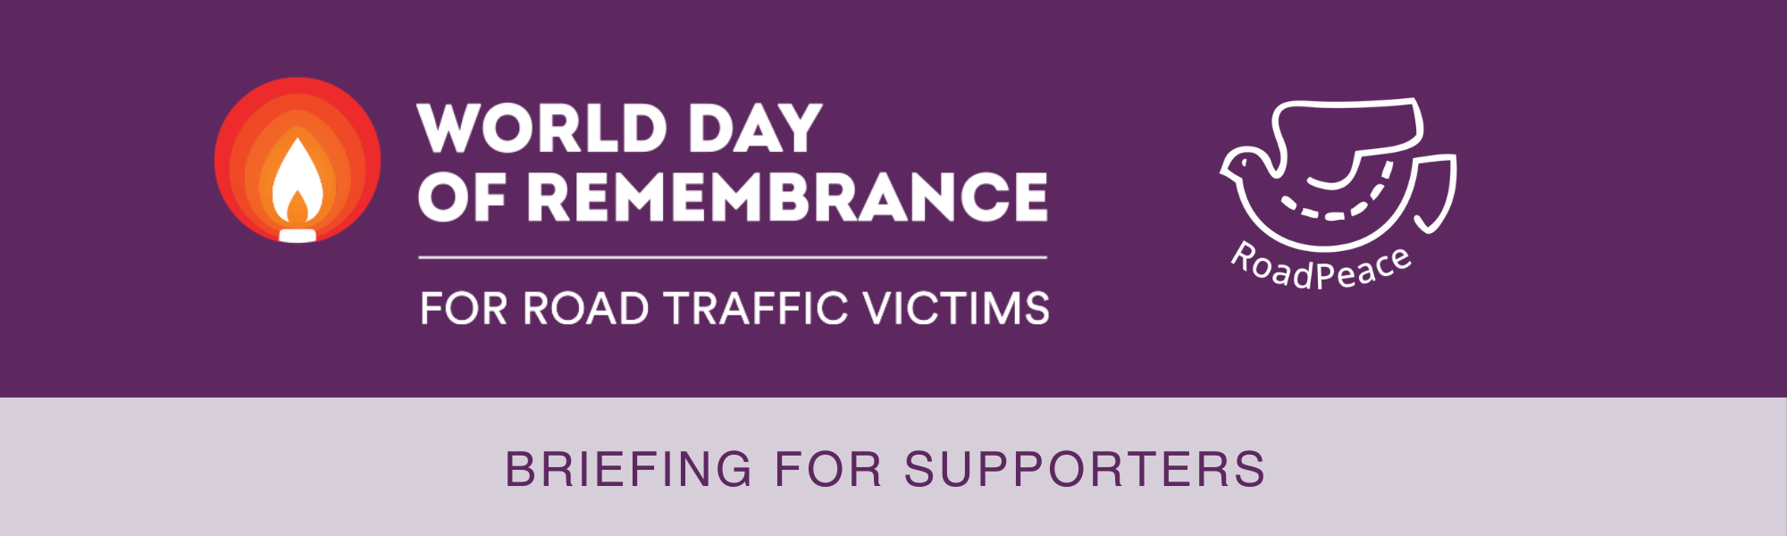

**Purpose and Significance**

World Day of Remembrance for Road Traffic Victims (WDoR) is a global event held annually on the third Sunday of November. It serves as a public acknowledgment of the devastating impact road deaths and injuries have on victims, their families and communities. This day is not just a moment of reflection for those who have suffered, but a collective recognition that honours their grief and affirms that their loss is shared by all of society.

**Origins and Evolution**

WDoR was initiated in 1993 by RoadPeace, in response to the lack of public recognition for road crash victims, who, unlike victims of crime, disaster or war, had not been offered a designated remembrance day. The day quickly garnered international support and became an essential moment for raising awareness about road danger, bereavement support and the suffering caused by road crashes.

In 2005, the United Nations General Assembly formally endorsed WDoR, urging all member states and the international community to observe this day and draw attention to the far-reaching consequences of road crashes.

Governments and individuals alike are reminded of their shared responsibility to prevent road traffic deaths and injuries.

**Why We Remember**

Road deaths are not 'normal' deaths - They are violent, sudden and premature, creating a deep trauma that affects families, friends and communities. Worldwide, nearly 4,000 people are killed every day in road crashes, and hundreds of thousands more are injured. The emotional and psychological impact on survivors and the bereaved is never-ending.

**Commemoration and Solidarity**

WDoR is a day of solidarity, bringing together bereaved families, survivors, road danger reduction advocates and the general public in remembrance.

WDoR focuses on:

* Remembering all the people killed and seriously injured on the roads
* Highlighting the often insufficient legal response to culpable road deaths and injuries
* Advocating for better support for road crash victims and their families
* Promoting evidence-based actions to prevent and eventually stop further road deaths and injuries
* Acknowledging the crucial work of the emergency services in responding to road crashes

**A Global Call for Change**

WDoR is observed in countries across every continent. By highlighting the profound consequences of road crashes, it aims to foster a global shift in attitudes towards road harm. Governments, policymakers and the public are called upon to take meaningful action to prevent road crashes, reduce injuries and save lives.

The event also serves as a platform for advocacy and public engagement. Organisations such as the World Health Organization (WHO), RoadPeace and the European Federation of Road Traffic Victims, encourage communities to organise events that honour victims and promote road danger reduction measures. Details of RoadPeace World Day of Remembrance Services can be found here: [**World Day of Remembrance - RoadPeace**](https://www.roadpeace.org/remembering-lives-lost/world-day-of-remembrance/) **Key Facts:**

* Approximately 1.19 million people are killed annually in road crashes
* Since the first WDoR in 1993, at least 36.8 million people have been killed in road traffic crashes worldwide
* Road traffic injuries are the leading cause of death for children and young adults aged 5 to 29 years worldwide
* More than half of all road traffic deaths are among vulnerable road users, including pedestrians, cyclists and motorcyclists*

**Conclusion**

The World Day of Remembrance for Road Traffic Victims is not only a day to remember those tragically killed, but also a powerful reminder of the need for concerted global action to make roads safer. It is a day of public reflection, recognition, and a commitment to reducing road traffic fatalities and injuries in the future.

*"A common Day of Remembrance offers solidarity and friendship to our fellow bereaved, draws attention to the devastation caused by road danger, and calls for an end to the carnage."* **Brigitte Chaudhry, Founder of RoadPeace & World Day of Remembrance for Road Traffic Victims**



info@roadpeace.org   
www.roadpeace.org

*[www.who.int/news-room/fact-sheets/detail/road-traffic-injuries](https://www.who.int/news-room/fact-sheets/detail/road-traffic-injuries)